**Problem A:**

1) 2A – B = <-2, -1, 0>

2) ||A|| = with angle 74.5 degrees relative to the x axis

3) A-hat = <1, 2, 3>

4) alpha = cos a = $\frac{1}{\sqrt{14}}$ = 0.267, beta = cos b = $\frac{2}{\sqrt{14}}$ = 0.267, ebsilon = cos b = = 0.267

5) A•B = B•A = 32

6) 12.93 degrees

7) <1,1,-1>

8) AxB = <-3,6,-3>, BxA = <3,-6,3>

9) <-3,6,-3>

10) Linearly Dependent: Gaussian Elimination: 

**Problem B:**

1) 

2) AB = BA = 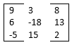

3) (AB) T = BTAT = 

4) |A| = 55, |C| = 0, So, matrix A is linearly independent because determinant is non-zero.

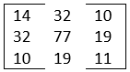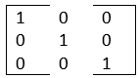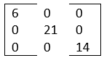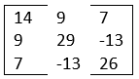5) If AAT = I then all the rows are orthogonal which makes the matrix an orthogonal set.

AAT = BBT = = CCT =

So, only matrix B has orthogonal rows.

6) A-1 =  B-1 = 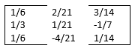

**Problem C:**

1) f’(x) = 2x f”(x) = 2

2) = 2x = 2y